Assignment 1:

A:

Declare

Var1 integer;

Var2 integer;

Var3 integer;

Begin

Var1 := &Var1;

Var2 := &Var2;

Var3 := (Var1 * Var2 / Var2);

DBMS_OUTPUT.PUT_LINE(Var3);

END;

/

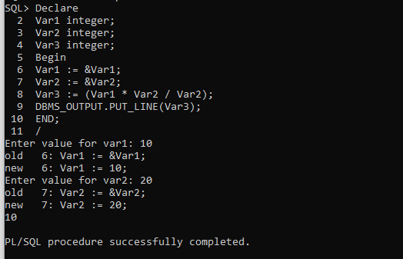

B:

Declare

MAX_SALARY number;

MIN_SALARY number;

DEPT_NO1 number;

DEPT_NO emp2.DEPTNO%TYPE;

CURSOR emp_cur IS SELECT DEPTNO FROM EMP2;

Begin

LOOP

FETCH emp_cur INTO dept_no;

EXIT WHEN emp_cursor%NOTFOUND;

DEPT_NO1 := &DEPT_NO1;

IF(DEPT_NO1 = dept_no)

MAX_SALARY := (SELECT MAX(SAL) from emp2 where deptno = DEPT_NO1);

MIN_SALARY := (SELECT MIN(SAL) from emp2 where deptno = DEPT_NO1);

END LOOP;

DBMS_OUTPUT.PUT_LINE(MAX_SALARY, MIN_SALARY);

End;

/

Assignment 2:

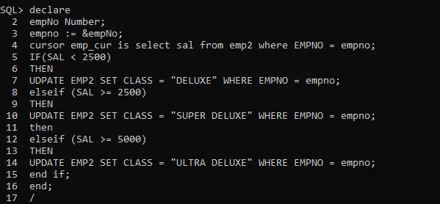

Assignment – 3

DECLARE

Type sarray IS VARRAY(5) OF INTEGER;

iX INTEGER(5);

n INTEGER(5);

a INTEGER(5);

checkEle INTEGER(5);

dis varchar2(20);

iarray sarray;

n := COUNT_ELEMENTS(iARRAY);

BEGIN

Ix: = & iX;

checkEle := &checkEle;

Iarray:= sarray(42, 88, 89, 62, 97);

FOR I in 1…n LOOP

If(iarray(i) = checkEle) then

Dis = iarray(i) + ‘ELEMENT FOUND’;

DBMS_OUTPUT.PUT_LINE(Dis);

Else

Dbms_output.put_line(‘element not found’);

FOR j in I LOOP

If(iarray(i) < iarray(i + 1) ) then

A = iarray(I + 1);

Iarray(I + 1) = iarray(i);

Iarray(i) = A;

END LOOP;

END LOOP;

DBMS_OUTPUT.PUT_LINE(iarray(ix));

End;

/

d.

DECLARE

Type sarray IS VARRAY(5) OF INTEGER(5);

Ix INTEGER(5);

N INTEGER(5);

L integer(5);

n := iarray.count;

BEGIN

Iarray := sarray(4,3 , 2, 1, 5);

Ix := &Ix;

Iarray.delete(ix);

L := iarray.count;

FOR I in 1…l LOOP

DBMS_OUTput.PUT_LINE(iarray(i));

End loop;

End;

/

Assignment 4:

declare cursor c1 is selectename ,sal, gradefromempe,salgradeswheree.sal >=s.losalande.sal<=s.hisal and rownum<=10 ;

emp_rec c1%rowtype; begin open c1;

loop fetch c1 into emp_rec;

exit when c1%NOTFOUND;

dbms_output.put_line(emp_rec.ename||''||emp_rec.sal||''|| emp_rec.grade);

end loop;

close c1;

end;

/

declare

cursor c1 is selectename ,sal, gradefromempe,salgradeswheree.sal>=s.losaland e.sal<=s.hisal and rownum<=10 ;

emp_rec c1%rowtype;

begin for emp_rec in c1 loop

dbms_output.put_line(emp_rec.ename||''||emp_rec.sal||''||emp_rec.grade);

end loop;

end;

/

c.

DECLARE

my_record emp22%ROWTYPE;

job VARCHAR2(30);

CURSOR c1 IS

SELECT ENAME, ESAL, DEPTNO FROM emp22;

BEGIN

OPEN c1(2000);

JOB := &JOB;

LOOP

FETCH c1 INTO my_record WHERE DNAME = JOB;

EXIT WHEN c1%NOTFOUND;

DBMS_OUTPUT.PUT_LINE('Name = ' ||my_record.ename || ', salary = '

|| my_record.sal || ‘deptno=’ || my_record.deptno);

END LOOP;

CLOSE c1;

END;

/

Assignment 6:

1. CREATE OR REPLACE FUNCTION VALIDATE_EMP(EMP_NO IN EMPNO %TYPE)

RETURN VARCHAR2(10)

IS

OUTPUT VARCHAR2((10);

BEGIN

If(EMP_NO = EMP.EMPNO)

THEN

RETURN TRUE;

ELSE

RETURN FALSE;

END;

/

b.

CREATE OR REPLACE FUNCTION CALCULATE_ROYALTY(EMP_NO IN EMPNO %TYPE)

RETURN VARCHAR2(10)

IS

OUTPUT VARCHAR2((10);

BEGIN

If(EMP_NO = EMP.EMPNO & DEPTNAME = ‘DEVELOPER’)

THEN

RETURN ‘HE IS A DEVELOPER’;

ELSE IF(EMP_NO = EMP.EMPNO & !DEPTNAME = ‘DEVELOPER’)

THEN

RETURN ‘1’;

ELSE IF(EMP_NO = EMP.EMPNO & DEPTNAME = ‘DEVELOPER’ & ROYALTYCOLUMN = NULL)

RETURN ‘2’;

END;

/